Thursday Bidding Tips 3 Board 17 played on 3/5/2018 Hamilton Williams Individual
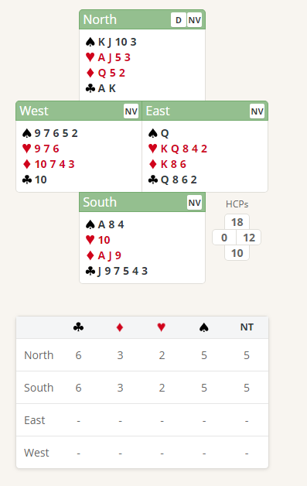
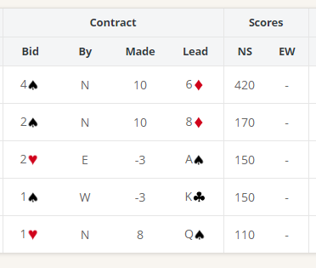

Suggested Bidding Players
N Dealer | E | S | W
1H | Pass | 2C | Pass
3NT | Pass | Pass | Pass

- Norths bid of 1 Heart shows 12-19 points and at least 4 Hearts.
- Souths reply of 2 Clubs shows 10+ points (bid an new suit at the 2 level) and at Least 4 Clubs ( denies having 4 Spades)
- North with 18 points now knows that there is at least 25 points, so game is on so bids 3 No Trumps (Shows 18 -19 points)
- South with 10 points now passes and North plays it in 3 NT (need at lest 34 points for slam)
Suggested Lead from East King Hearts (promises at least the Queen). Alternatively, east could lead low Club

